MIDTOWNERS SUNSHINE OF THE WEEK ► July 27th, 2007
Birthday of Rtn. Ranjit Acharya on August 1st

SPEAKER OF THE WEEK ► Ms. Caroline Jacoby
THEME | What's new in maternal health
Caroline Jacoby, MPH, is a Senior Program Officer for the Johns Hopkins Bloomberg School of Public Health/ Center for Communication Programs (JHU/CCP). She has been in Nepal with JHU/CCP under the DFID-funded Support to Safe Motherhood Program for the last 18 months and her office is located in the National Health Education, Information and Communication Center (NHEICC). She has been working in health communication at JHU since 2000 on programs in Nepal and Bangladesh. Before that she enjoyed two years as a Peace Corps Volunteer in Darchula District in western Nepal.

UPCOMING SPEAKERS ► PREVIEW
DATE | SPEAKER | THEME
Aug 3rd | CLUB ASSEMBLY | First Club Assembly of this year
Aug 10th | Mr. Rajeev Adhikari  Sr. Consultant, Total Management Service | Donor driven Development
Aug 17th | Ms. Trishna Gurung  Communications and Marketing Manager, WWF Nepal | Global Climate Change

THE MID-TOWN CLUB ► NEWS
Last Week’s Talk
Last week’s speaker Mr. Pramod Paudel talked about the superior quality of Nepali high altitude coffee and its potential in the world specialty coffee market. He also discussed about possible factors that were hindering the growth of coffee export in Nepal.

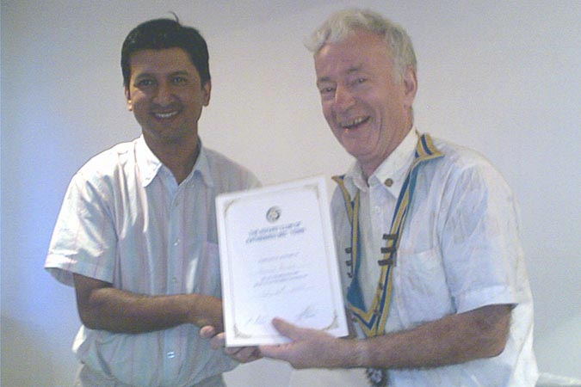

President Walter handing the Letter of Appreciation to Mr. Poudel

THE ROTARY INTERNATIONAL ► NEWS
Get to know your RI President
Wilfrid J. Wilkinson, a retired chartered accountant, was a founding partner of Wilkinson & Company, a public accounting firm. He is a past president of the Public Accountants Council for the Province of Ontario and a past treasurer of both the Canadian Institute of Chartered Accountants and the Institute of Chartered Accountants of Ontario. He is also a member of the Institute of Chartered Accountants of Quebec and the Royal Canadian Military Institute and was elected a fellow of the Ontario Institute of Chartered Accountants.
Since retiring, Wilkinson has served as the part-time executive director of the Quinte Ballet School of Canada. He is also a member of the board of directors of Morris Industries Ltd., a company that manufactures advanced air seedings and tillage systems. He has also been chairman of the Trenton Memorial Hospital fundraising committee, a founding chairman of the Belleville Cheshire Home for Physically Handicapped Adults, chairman of the Board for Loyalist College, and president of the district council of the Boy Scouts of Canada.
A Rotarian since 1962, Wilkinson is a member and past president of the Rotary Club of Trenton, Ontario. He has served Rotary International as vice president, director, Rotary Foundation trustee, and district governor. He has also been an International Assembly discussion leader and member and chair of several committees, including the 2005 Chicago Convention Committee.
As a member of the International PolioPlus Committee, Wilkinson has been dedicated to the global effort to eradicate polio. He participated in National Immunization Days in Kenya, Tanzania, and India, and also administered polio drops to children of Afghan refugees in Pakistan. He has served as a Health, Hunger and Humanity Grants program volunteer to India. In addition, Wilkinson has had Rotary assignments in South Africa, Namibia, the United Kingdom, Europe, Australia, New Zealand, and many regions throughout the United States and Canada.
Wilkinson has been recognized for his humanitarian service by the Knights of Columbus, the province of Ontario, and the Canadian government. In 2001, he was honored by Pope John Paul II with the Pro Ecclesia et Pontifice medal. He is also the recipient of numerous Rotary honors, including RI’s Service Above Self Award and the Foundation’s Citation for Meritorious Service, Distinguished Service Award, and International Service Award for a Polio-Free World.
Wilkinson has been married to Joan since 1953, and they have four sons and eight grandchildren.

Did you know?
The following famous people have been active or honorary Rotary members:
1. Neil Armstrong, astronaut and first man to walk on the moon
2. Sir Winston Churchill, British prime minister
3. Walt Disney, animation filmmaker
4. Thomas A. Edison, inventor
5. John F. Kennedy, U.S. president
6. Prince Philip, Duke of Edinburgh
7. Prince Rainier III of Monaco
8. Margaret Thatcher, British prime minister
9. Claude Vuitton, owner, Vuitton luggage enterprise
10. Orville Wright, aviation pioneer
Editor: Rabi Karmacharya, Club Service Director email: rabikarma@gmailcom

